Project Synopsis

on

**Sab Kuchh**

Submitted as a part of course curriculum for

**Bachelor of Technology**

in

**Computer Science**



**Submitted by**

Hardik Soni (2000290120068)

Gaurav Dubey(2000290120065)

Pushkar Saraswat (2100290129006)

**Under the Supervision of**

Prof. Shivani

Assistant Professor

**KIET Group of Institutions, Ghaziabad**

**Department of Computer Science**

**Dr. A.P.J. Abdul Kalam Technical University**

**2022-2023**

**i**

**DECLARATION**

We hereby declare that this submission is our work and that, to the best of our knowledge and belief, it contains no material previously published or written by another person nor material which to a substantial extent has been accepted for the award of any other degree or diploma of the university or other institute of higher learning, except where due acknowledgement has been made in the text.

Signature of Students:

Name : Hardik Soni Gaurav Dubey Pushkar Saraswat

Roll No. : 2000290120068 20002901200065 2100290129006

Date : 11-11-22

**ii**

**CERTIFICATE**

This is to certify that Project Report entitled “**Sab kuchh**” which is submitted by **Gaurav Dubey, Hardik Soni And Pushkar Saraswat** in partial fulfilment of the requirement for the award of degree B. Tech. in Department of Computer Science of Dr A.P.J. Abdul Kalam Technical University, Lucknow is a record of the candidates own work carried out by them under my supervision. The matter embodied in this report is original and has not been submitted for the award of any other degree.

**Date: 11-11-22 Supervisor Signature**

Prof. Shivani

(Assistant Professor)

**iii**

**ACKNOWLEDGEMENT**

It gives us a great sense of pleasure to present the synopsis of the B. Tech Mini Project undertaken during B.Tech. Third Year. We owe a special debt of gratitude to Prof. Shivani (Assistant Professor), Department of Computer Science, KIET Group of Institutions, Delhi- NCR, Ghaziabad, for his/her constant support and guidance throughout the course of our work. Her sincerity, thoroughness and perseverance have been a constant source of inspiration for us. It is only his/her cognizant efforts that our endeavours have seen the light of the day.

We also take the opportunity to acknowledge the contribution of Dr. Ajay Kumar Srivastava, Head of the Department of Computer Science, KIET Group of Institutions, Delhi- NCR, Ghaziabad, for his full support and assistance during the development of the project. We also do not like to miss the opportunity to acknowledge the contribution of all the faculty members of the department for their kind assistance and cooperation during the development of our project.

Last but not the least, we acknowledge our friends for their contribution to the completion of the project.

Signature:

Name : Hardik Soni Gaurav Dubey Pushkar Saraswat

Roll No. : 2000290120068 20002901200065 2100290129006

Date : 11-11-22

**iv**

**ABSTRACT**

An e-commerce website that permits a customer to purchase orders for items and/or services from a store that serves both walk-in customers and online customers. This online shopping system presents display of items that are delivered by different shopkeepers from the nearby area for the searched items by the customers. The system accepts the customer's submission of a purchase order through. This online shopping system does not settle with an input request of the customer until the item selected by the customer is found in a set of nearby location, if the item is not found it will display not found. Therefore, the customer can physically visit the place for purchasing the order.

v

**LIST OF FIGURES**

Figure 3.1 Flowchart

Figure 5.1 Register page

Figure 5.2 Login page

Figure 5.3 Home page

Figure 5.4 Product page

Figure 5.5 Product description page

**vi**

**TABLE OF CONTENTS**

|  |  |
| --- | --- |
|  | Page No. |
| TITLE PAGE .................................................................................................................... | i |
| DECLARATION .............................................................................................................. | ii |
| CERTIFICATE …........................................................................................................... | iii |
| ACKNOWLEDGEMENT.................................................................................................. | iv |
| ABSTRACT...................................................................................................................... | v |
| LIST OF FIGURES ......................................................................................................... | vi |
|  |  |
| CHAPTER 1 INTRODUCTION | 1 |
| 1.1.          Introduction ……………………................................................... | 1 |
| 1.2 Problem Statement.……………………....................................... | 1 |
| 1.3.          Objective………………………………………………………… | 1 |
| 1.4.          Scope……………………………………………………………. | 2 |
| CHAPTER 2 LITERATURE REVIEW…………………………………………….... | 3 |
| CHAPTER 3 PROPOSED METHODOLOGY …………………………………........ | 5 |
| 3.1 Flowchart |  |
|  |  |
| CHAPTER 4 TECHNOLOGY USED ………..………………………..………………. | 7 |
| CHAPTER 5 SCREENSHOTS…...................................................................................... | 9 |
| CHAPTER 6 CONCLUSION …....................................................................................... | 12 |
| REFERENCES…............................................................................................................... | 13 |

**vii**

**Chapter 1: Introduction**

* 1. **Introduction**

Business activities have become more convenient and efficient as technology has advanced, and the world has shrunk to the size of a village. People all over the world can now connect easily and quickly thanks to the introduction of smartphones. A buyer in the United States can review and buy an item from China and have it delivered to his door. Similarly, a seller can advertise and sell a product to a large number of customers worldwide without having to travel. Thus, e-commerce refers to the ability to conduct business transactions without the seller and buyer coming into physical contact.

Businesses around the world are now faced with the choice of adapting to ever-changing technological advancements or becoming obsolete by remaining rooted in brick-and-mortar tradition. Enterprises are now struggling to compete with online shopping companies like Amazon, which rely entirely on e-commerce. With this project we are going to provide solution to various retailers and shopkeepers by making easy for them to attract the customers who live in the nearby locations to purchase the items they are looking for in the lowest price and from the nearest location.

In this project, we will provide services to the customers based on choice of item they want to purchase. Our project is all about making a website to satisfy the customers with their demands in the least amount and within the least distance (by identifying shortest possible path to reach the place).

* 1. **Problem Statement**

The motive of this project is to basically find any thing legally sold in the market example, mouse, bottle, pen drive, laptop and many more items. The searching of these items will be based on keywords/ Google scanner to scan the image of the product. The output of the website will be all the nearby locations selling those items/products. The results will be sorted based on the distance and prices. Then, the customer may either visit the shop to purchase the product.

* 1. **Objective**

This website will be one stop solution for the customers as it will:

* Compare the prices of the item searched by the customers in an efficient manner
* Provide a choice to the customer to either search the item through company name, product name or via image through google scanner.
* Help the retailers and shopkeepers to expand their network by connecting to the local customers with the help of technology
* Satisfy the customer with the product availability in least price and from the nearest location.

**1**

* 1. **Scope**

After discussion with the team and with our guide, we can consider the scope of this project as follows :

* It will give an Opportunity to Retailers/ shopkeepers to be recognized and their product visibility will increase in a particular area.
* Customers will have more faith over the nearby shopkeepers and will be satisfied by relying on their products.

2

**Chapter-2: Literature Review**

ASSOCHAM Study (2015) found the highest growth rate in the apparel segment, almost 69.5 per cent over 2014, followed by electronic items, up 62 per cent, baby care products, up 53 per cent, beauty and personal care products at 52 per cent and home furnishings at 49 per cent. Rapid growth of digital commerce in India is mainly due to increased use of smartphones. Mobiles and mobile accessories have taken up the maximum share of the digital commerce market in India, noted the study. Moreover, almost 45 per cent online shoppers reportedly preferred cash on delivery over credit cards (16 per cent) and debit cards (21 per cent). Only 10 per cent opted for internet banking and a scanty 7 per cent preferred cash cards, mobile wallets, and other such modes of payment. The 18-25 years of age group has been the fastest growing age segment online with user growth being contributed by both male and female segments. The survey highlights that 38 per cent of regular shoppers are in 18-25 age group, 52 per cent in 26-35, 8 per cent in 36-45 and 2 per cent in the age group of 45-60. Nearly 65 per cent online shoppers are male and 35 per cent female.

Mitra Abhijit (2013) suggests E-Commerce has unleashed yet another revolution, which is changing the way businesses buy and sell products and services. New methodologies have evolved. The role of geographic distances in forming business relationships is reduced. E-Commerce is the future of shopping. With the deployment of 3G and 4G wireless communication technologies, the internet economy will continue to grow robustly. In the next 3 to 5 years, India will have 30 to 70 million internet users which will equal, if not surpass, many of the developed countries. Internet economy will then become more meaningful in India. With the rapid expansion of internet, Ecommerce is set to play a very important role in the 21st century, the new opportunities that will be thrown open, will be accessible to both large corporations and small companies. The role of government is to provide a legal framework for E-Commerce so that while domestic and international trade are allowed to expand their horizons, basic rights such as privacy, intellectual property, prevention of fraud, consumer protection etc are all taken care of.

Chanana Nisha and Goele Sangeeta (2012) propose that the future of E-Commerce is difficult to predict. There are various segments that would grow in the future like: Travel and Tourism, electronic appliances, hardware products and apparel. There are also some essential factors which will significantly contribute to the boom of the E-Commerce industry in India i.e. replacement guarantee, M-Commerce services, location based services, multiple payment option, right content, shipment option, legal requirement of generating invoices for online transactions, quick Service, T & C should be clear & realistic, the product quality should be same as shown on the portal, dedicated 24/7 customer care centre should be there.

Awais Muhammad and Samin Tanzila (2012) indicate that use of internet has made the world a global village. The use of Internet has reduced the distances and brought the people together. A nation’s back bone is commerce and it will be strengthened if backed by electronic tools in which e-commerce plays a vital role. The important feature in ecommerce is privacy which not only increases competitive advantage but confidence

level also. E-commerce brings sellers and potential buyers at the distance of one click and it saves time as it is cost effective, as E-commerce is becoming key to success.

Dutta and Dutta, (2009) found tangibles have the highest impact on overall customer satisfaction. The largest discrepancy between the customer expectations and perceptions is in terms of empathy which includes Bank locations and ATM machines in convenient places and telebanking and internet banking facility. The study regards this a major source of concern for Indian banking industry as a huge service quality gap exists for all the banks in this category.

Kumar and Rajesh (2009) suggest that the facilities of the banks should be made more convenient for customer comforts. The ATM services should be extended with few more cabins. 8 The work also concludes that with sincere efforts and positive attitude, the needs of many customers can be satisfied when banks aim at ‘customer delight’.

Blasio (2008), in his study does not find the support for the argument that the Internet reduces the role of distance. Internet usage is much more frequent among urban consumers than among their non-urban counterparts. The use of e-commerce is basically unaffected by the size of the city where the household lives. Geographically remote consumers are discouraged from purchasing goods by the fact that they cannot inspect them beforehand. Leisure activities and cultural items (i.e., books, CDs, and tickets for museums and theaters) are the only goods and services for which e-commerce is used more in isolated areas. Finally, e-banking bears no relationship to city size. In choosing a bank, non-urban customers give more importance to personal acquaintance than do urban clients, partly because bank account holders in remote areas are more likely to have taken out a loan from their bank.

4

**Chapter-3: Proposed Methodology**

Methodology includes the introduction of different modules that we are going to incorporate in our website.

**Authentication:**

Authentication is the process of identifying users that request access to a system, network, or device. Access control often determines user identity according to credentials like username and password. Other authentication technologies like biometrics and authentication apps are also used to authenticate user identity.

**Search Engine Optimization:**

We will use the Search Engine Optimization to do the following:

* + - 100% Search Engine Friendly
    - Google Site Map
    - URL Rewrites give full control of URL’s
    - Meta_information for products and categories
    - Auto-generated Site Map for display on site
    - Auto-Generated Popular Search Terms Page

**Customer Module:**

Customers will be able to create an account on our website and do seamless searching.

**Seller Module:**

Different vendors will be able to create an account on our website and add the details of the products they are selling.

**Product Management:**

* + - Minimum Price Product
    - Add main product details and additional information
    - Add unlimited product options/sizes with custom prices
    - Add your products to unlimited shop categories
    - Product images module
    - Product SEO customization
    - Manufacturers and brand management

**3.1 FLOWCHART** :

5

**Chapter-4: Technology used**

**React:**

React (also known as React.js or ReactJS) is a free and open-source front-end JavaScript library for building user interfaces based on UI components. It is maintained by Meta (formerly Facebook) and a community of individual developers and companies.React can be used as a base in the development of single-page, mobile, or server-rendered applications with frameworks like Next.js. However, React is only concerned with state management and rendering that state to the DOM, so creating React applications usually requires the use of additional libraries for routing, as well as certain client-side functionality.

**Javascript:**

JavaScript is a dynamic programming language that's used for web development, in web applications, for game development, and lots more. It allows you to implement dynamic features on web pages that cannot be done with only HTML and CSS.

Many browsers use JavaScript as a scripting language for doing dynamic things on the web. Any time you see a click-to-show dropdown menu, extra content added to a page, and dynamically changing element colors on a page, to name a few features, you're seeing the effects of JavaScript.

There are two ways to use JavaScript in an HTML file. The first one involves embedding all the JavaScript code in the HTML code, while the second method makes use of a separate JavaScript file that’s called from within a Script element, i.e., enclosed by Script tags. JavaScript files are identified by the .js extension. Although JavaScript is mostly used to interact with HTML objects, it can also be made to interact with other non-HTML objects such as browser plugins, CSS (Cascading Style Sheets) properties, the current date, or the browser itself. To write JavaScript code, all you need is a basic text editor like Notepad in Windows, Gimp in Linux, or BBEdit. Some text editors, like BBEdit feature syntax highlighting for JavaScript. This will allow you easily identify elements of JavaScript code. The latest versions of Internet Explorer, Firefox, and Opera all support JavaScript.

**MongoDB:**

MongoDB is an open-source document-oriented database that is designed to store a large scale of data and also allows you to work with that data very efficiently. It is categorized under the NoSQL (Not only SQL) database because the storage and retrieval of data in the MongoDB are not in the form of tables.

The MongoDB database is developed and managed by MongoDB.Inc under SSPL(Server Side Public License) and initially released in February 2009. It also provides official driver support for all the popular languages like C, C++, C#, and .Net, Go, Java, Node.js, Perl, PHP, Python, Motor, Ruby, Scala, Swift, Mongoid. So, that you can create an application using any of these

languages. Nowadays there are so many companies that used MongoDB like Facebook, Nokia, eBay, Adobe, Google, etc. to store their large amount of data.

Node.js:

Node.js (Node) is an open source development platform for executing JavaScript code server-side. Node is useful for developing applications that require a persistent connection from the browser to the server and is often used for real-time applications such as chat, news feeds and web push notifications.

Node.js is intended to run on a dedicated HTTP server and to employ a single thread with one process at a time. Node.js applications are event-based and run asynchronously. Code built on the Node platform does not follow the traditional model of receive, process, send, wait, receive. Instead, Node processes incoming requests in a constant event stack and sends small requests one after the other without waiting for responses.

This is a shift away from mainstream models that run larger, more complex processes and run several threads concurrently, with each thread waiting for its appropriate response before moving on.

8

**Chapter-5: Screenshots**

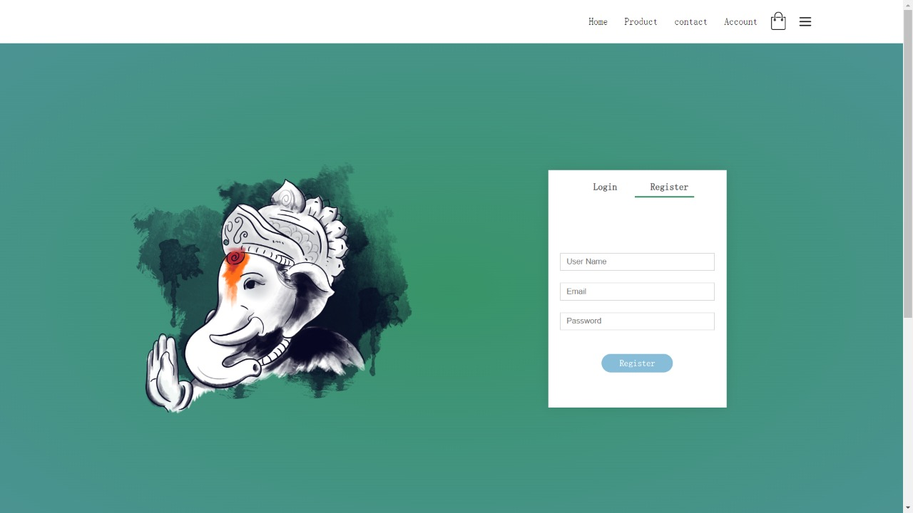

Figure5.1 Register page

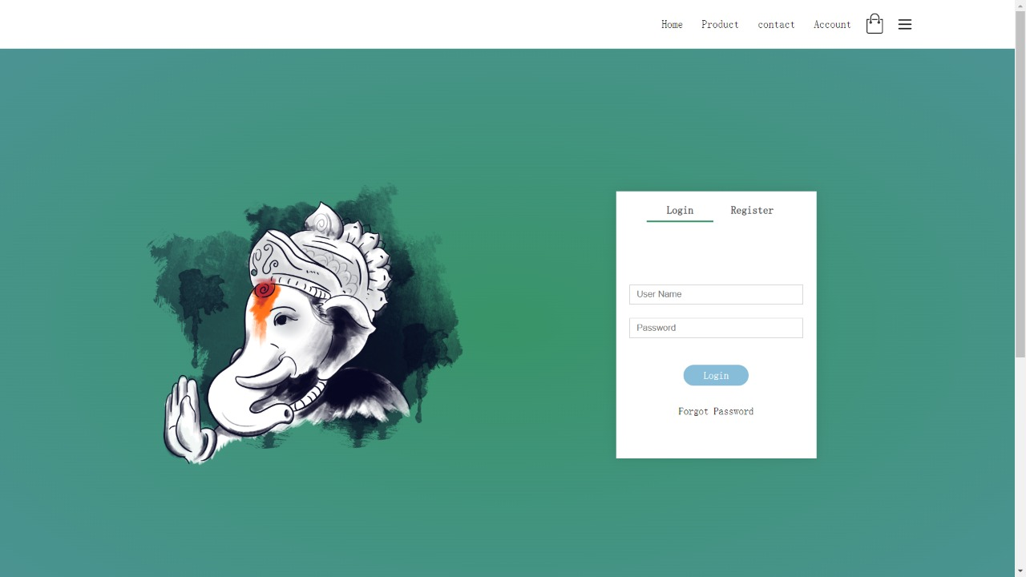

Figure5.2 Login page

9

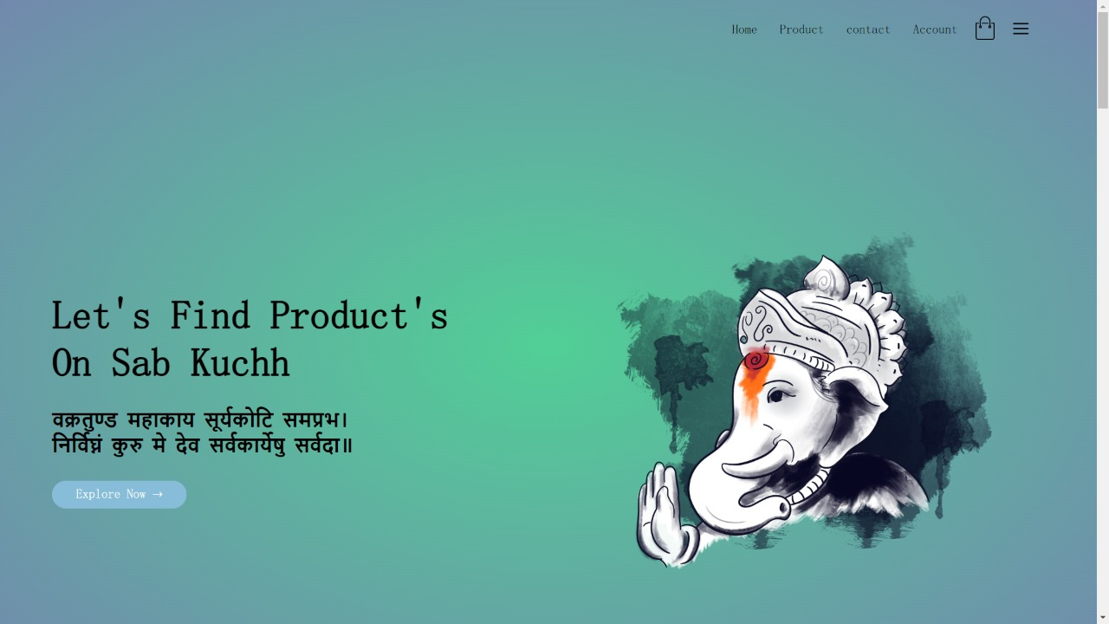

Figure5.3 Home page

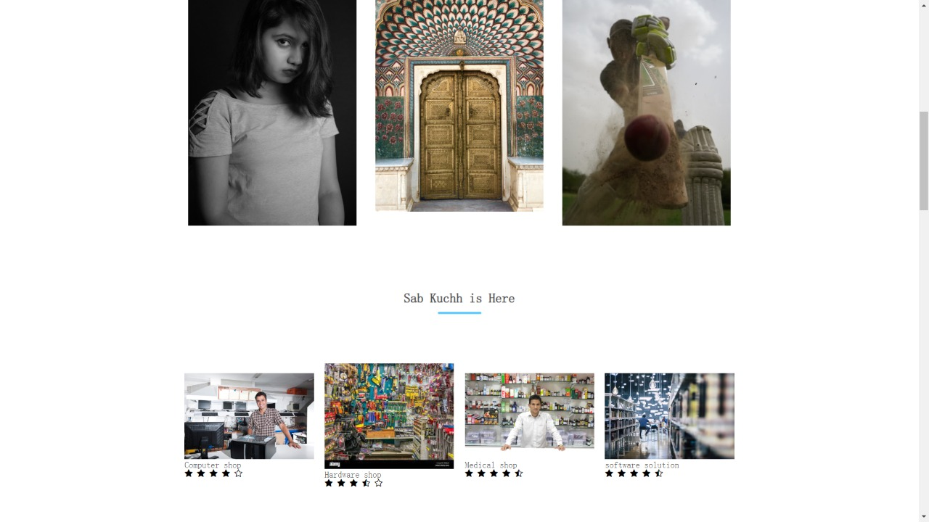

Figure5.4 Product page

10

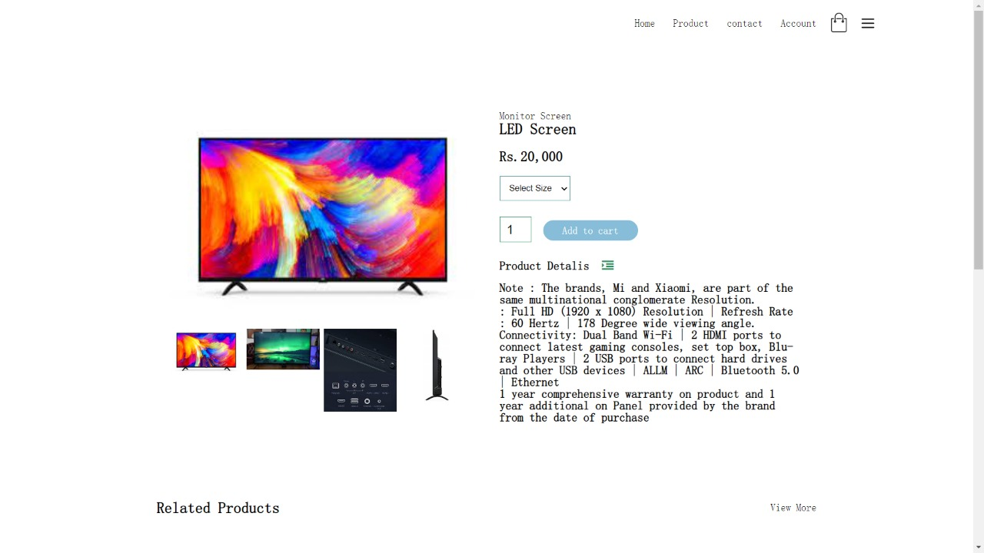

Figure5.5 Product description page

11

**CHAPTER-6: CONCLUSION**

E-Commerce is a boon for any country- if given right impetus and good environmental framework to prosper can significantly lead to country’s progress and development. Through our project we have tried to help the local shopkeepers to establish a connection with the technology and increase their income by letting the customer know about the product availability at their shops at affordable price.

12

**REFERENCES**

1. Awais Muhammad and Samin Tanzila (2012), “Advanced SWOT Analysis of ECommerce”, IJCSI International Journal of Computer science Issues, Vol 9,Issue 2,No 2,pp. 569-574
2. Blasio,G.,D. (2008), “Urban–Rural Differences in Internet Usage, e-Commerce, and eBanking: Evidence from Italy”, Growth and Change, 39.2 , pp. 341–367
3. Chanana Nisha and Goele Sangeeta, “Future of e-commerce in India”, International Journal of Computing & Business Research, ISSN (Online): 2229-6166
4. Chou,D.,C. and Chou,A.,Y. (2000), “The E-Commerce Revolution, A Guide to the Internet Revolution in Banking” information systems management,pp.51-57
5. D’silva,B., D’Silva,S., and Bhuptani,R.,S.,K.(2010), “Behavioral Aspect of Teenagers Towards Internet Banking: An empirical study”, Indian journal of marketing, 40.10, pp.44-53
6. Dutta and Dutta (2009) “A Study on Customer Perception towards HDFC Limited” International Journal of Management Sciences and Business Research Volume 2, Issue 4- ISSN (2226-8235)
7. Hsieh,C. (2005), “Implementing Self-Service Technology To Gain Competitive Advantages” Communications of the IIMA,5.1,pp.77-83
8. Strauss, J., Ansary,A., E., and Frost,R.(2007), E marketing, Prentice Hall of India private limited, New Delhi
9. Snellman and Vihtkari (2003) "Customer complaining behaviour in technology‐based service encounters", International Journal of Service Industry Management, Vol. 14 Iss: 2, pp.217 - 231
10. Rust,R.,T., and Chung,T.,S. (2006) “Marketing Models of Service and Relationships” Marketing science,25.6, pp. 560-580

13

Start

Customer

Seller

NO NO

Login

Register

Login

Register

s

Keywords/

Google

scan image

Add Category

Add Product

Add Location And contact details

Stop

Logout

Product Detail and Locations

Search Product

View Product

Figure 3.1

6